SIMATS ENGINEERING
ASSESSMENT TOOL 2

COURSE NAME: INTERNET PROGRAMMING
COURSE CODE: CSA43
NAME: K.Nagesh Reddy
REG NO: 192325083

COURSE OUTCOME COVERED

CO -2 : Apply CSS layout and styling techniques to create visually appealing and responsive web interfaces, and use JavaScript to enable interactive client-side behavior. (L3)

Assessment Tool : Design Task

Weightage: 20%

QUESTIONS: Total Marks: 20

Question 1: Responsive Navigation Bar Design - Marks(4)
Suppose that an e-commerce website requires a responsive navigation bar that adapts across desktop, tablet, and mobile devices.
(a) Identify key components required in a navigation bar for an e-commerce website.
(b) Design a responsive navigation bar using appropriate CSS techniques.
(c) Demonstrate how the navigation adapts to smaller screens (e.g., hamburger menu).
(d) Evaluate the usability and suggest improvements for better user experience.

(a) Key Components Required in an E-commerce Navigation Bar
The key components of an e-commerce navigation bar are:
- Logo: Identifies the brand and links to the home page.
- Navigation Links: Provides links to Home, Products, Categories, Offers, and Contact pages.
- Search Bar: Helps users find products quickly.
- User Account: Allows users to log in and manage their accounts.
- Shopping Cart: Displays selected products and the total number of items.
- Responsive Menu: Provides a hamburger menu on smaller screens.
(b) Design a Responsive Navigation Bar Using CSS
HTML and CSS can be used to create a responsive navigation bar. Flexbox helps arrange the navigation elements horizontally on larger screens.
HTML Code:

<!DOCTYPE html>
<html>
<head>
<title>E-commerce Navigation</title>
<meta name="viewport"
content="width=device-width, initial-scale=1.0">
<link rel="stylesheet" href="style.css">
</head>
<body>

<nav class="navbar">
<div class="logo">ShopEasy</div>

<input type="checkbox" id="menu-toggle">
<label for="menu-toggle" class="hamburger">&#9776;</label>

<ul class="nav-links">
<li><a href="#">Home</a></li>
<li><a href="#">Products</a></li>
<li><a href="#">Offers</a></li>
<li><a href="#">Contact</a></li>
</ul>

<div class="cart">
<a href="#">Cart 🛒</a>
</div>
</nav>

</body>
</html>

CSS Code (style.css):
* {
margin: 0;
padding: 0;
box-sizing: border-box;
}

.navbar {
display: flex;
justify-content: space-between;
align-items: center;
background: #222;
color: white;
padding: 15px 25px;
}

.logo {
font-size: 24px;
font-weight: bold;
}

.nav-links {
display: flex;
list-style: none;
gap: 20px;
}

.nav-links a,
.cart a {
color: white;
text-decoration: none;
}

.nav-links a:hover,
.cart a:hover {
color: orange;
}

#menu-toggle,
.hamburger {
display: none;
}

@media (max-width: 768px) {
.hamburger {
display: block;
font-size: 25px;
cursor: pointer;
}

.nav-links {
display: none;
flex-direction: column;
position: absolute;
top: 60px;
left: 0;
width: 100%;
background: #222;
padding: 15px;
}

#menu-toggle:checked ~ .nav-links {
display: flex;
}

.cart {
display: none;
}
}
(c) Demonstration of Responsive Navigation
The navigation bar adapts to different screen sizes using CSS media queries.
- Desktop: The logo, navigation links, and shopping cart appear horizontally.
- Tablet: The layout adjusts to fit the available screen width.
- Mobile: When the screen width is 768 pixels or less, the navigation links are hidden and a hamburger icon appears. Clicking the icon displays the navigation links.
The checkbox and CSS selector :checked control the hamburger menu without requiring JavaScript.
(d) Usability Evaluation and Improvements
The responsive navigation bar provides easy access to important pages and saves screen space on mobile devices. Flexbox maintains proper alignment, while media queries adapt the layout to different screen sizes.
Suggested improvements:
- Add a visible search icon or expandable search bar on mobile devices.
- Display the shopping cart icon on mobile screens.
- Improve accessibility by adding keyboard navigation and clear focus indicators.
- Use sufficient color contrast and appropriately sized buttons.
- Ensure the hamburger menu has an accessible label and a clear open/close state.
Conclusion: A responsive navigation bar improves accessibility, usability, and the shopping experience across desktop, tablet, and mobile devices.
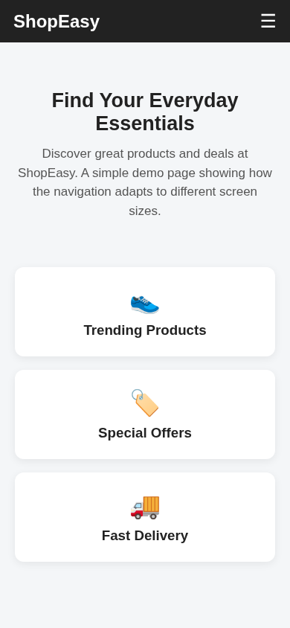
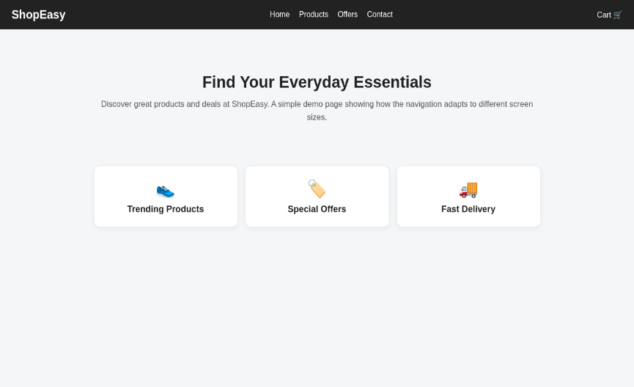

Question 2: Product Hover Effect - Marks(4)
Suppose that an e-commerce website wants to enhance user interaction through visual effects on product items.
(a) Identify suitable CSS properties for hover effects.
(b) Suggest appropriate CSS animation or transition for product interaction.
(c) Design a hover effect for a product card.
(d) Evaluate performance and user experience considerations.

(a) Identify Suitable CSS Properties for Hover Effects
The following CSS properties are used to create hover effects:
- transform – Changes the size or position of a product card.
- box-shadow – Adds a shadow to the product card.
- transition – Creates smooth visual changes.
- background-color – Changes the background color.
- :hover – Applies styles when the mouse pointer moves over an element.
(b) Suggest Appropriate CSS Animation or Transition
The CSS transition property creates smooth effects when users interact with products.
Example:
.product {
transition: 0.3s;
}

.product:hover {
transform: scale(1.05);
box-shadow: 0 5px 15px gray;
}
Explanation: The product card becomes slightly larger and displays a stronger shadow when hovered over.
(c) Design a Hover Effect for a Product Card
HTML Code (index.html)
<!DOCTYPE html>
<html>
<head>
<title>Product Hover Effect</title>
<link rel="stylesheet" href="style.css">
</head>
<body>

<h2>Product Card</h2>

<div class="product">
<h3>Wireless Headphones</h3>
<p>Price: ₹999</p>
<button>Add to Cart</button>
</div>

</body>
</html>
CSS Code (style.css)
body {
font-family: Arial;
text-align: center;
background-color: lightgray;
}

.product {
width: 250px;
margin: 50px auto;
padding: 20px;
background-color: white;
border-radius: 10px;
box-shadow: 0 2px 5px gray;
transition: 0.3s;
}

.product:hover {
background-color: lightyellow;
transform: scale(1.05);
box-shadow: 0 5px 15px gray;
}

button {
background-color: blue;
color: white;
padding: 10px;
border: none;
cursor: pointer;
}

button:hover {
background-color: green;
}
Output: Initially, the product card has a white background. When the user hovers over it, the background changes to light yellow, the card becomes slightly larger, and its shadow increases. The button changes from blue to green when hovered over.
(d) Evaluate Performance and User Experience Considerations
Performance:
- Use transform and opacity for efficient animations.
- Keep transition durations short, around 0.2–0.3 seconds.
- Avoid excessive animations that may affect performance.
User Experience:
- Hover effects make products more interactive and attractive.
- Smooth transitions improve the browsing experience.
- Buttons should provide clear visual feedback.
- Hover effects should not be the only way to access information because touchscreen devices do not support conventional mouse hovering.
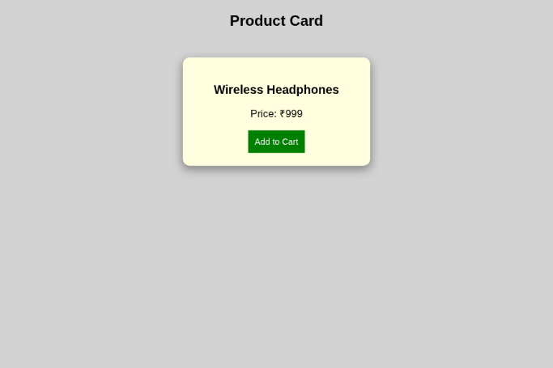
Conclusion: CSS hover effects improve product interaction and visual appearance while maintaining a simple and responsive user interface.

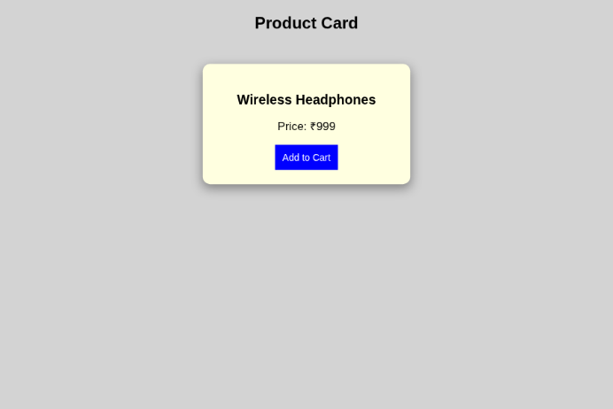

Question 3: Layout Selection (Flexbox vs Grid) - Marks(4)
Suppose that a dashboard layout needs to be designed for a web application.
(a) Identify layout requirements of a dashboard (rows, columns, alignment).
(b) Compare Flexbox and Grid based on layout needs.
(c) Choose the most suitable layout technique and justify your choice.
(d) Evaluate the scalability and responsiveness of the chosen approach.

(a) Identify Layout Requirements of a Dashboard
A dashboard requires a well-organized layout to display information clearly.
- Rows and Columns: Arrange charts, cards, and data tables.
- Alignment: Align elements properly using consistent spacing.
- Responsive Design: Adjust the layout for desktop, tablet, and mobile screens.
- Flexible Structure: Allow new components to be added easily.
(b) Compare Flexbox and Grid
Flexbox | CSS Grid
One-dimensional layout (row or column). | Two-dimensional layout (rows and columns).
Suitable for navigation bars and buttons. | Suitable for dashboards and complex layouts.
Aligns items along one main axis. | Controls rows and columns simultaneously.
Best for arranging elements in a single direction. | Best for arranging multiple dashboard sections.
(c) Choose the Most Suitable Layout Technique
CSS Grid is the most suitable technique for a dashboard because it arranges elements into rows and columns.
Example CSS:
.dashboard {
display: grid;
grid-template-columns: repeat(3, 1fr);
gap: 15px;
}

.card {
background: lightblue;
padding: 20px;
text-align: center;
}
Example HTML:
<div class="dashboard">
<div class="card">Users</div>
<div class="card">Sales</div>
<div class="card">Revenue</div>
</div>
This creates three equal-width columns with spacing between the cards.
(d) Evaluate Scalability and Responsiveness
- Scalability: New cards and sections can be added easily to the grid.
- Responsiveness: Media queries can change the number of columns based on screen size.
- Maintainability: CSS Grid makes complex dashboard layouts easier to organize.
- User Experience: Proper spacing and alignment improve readability.
Example responsive CSS:
@media (max-width: 600px) {
.dashboard {
grid-template-columns: 1fr;
}
}
Conclusion: CSS Grid is ideal for dashboard layouts because it provides precise control over rows and columns while supporting scalability and responsive design.

Question 4: Mobile-First Blog Layout - Marks(4)
Suppose that a blog page must be designed following a mobile-first approach.
(a) Identify key sections of a blog layout.
(b) Design a mobile-first layout using CSS.
(c) Demonstrate how the layout scales for larger screens using media queries.
(d) Evaluate accessibility and readability of the design.

(a) Identify Key Sections of a Blog Layout
A blog page contains the following sections:
- Header: Displays the blog title or logo.
- Navigation Bar: Provides links to Home, About, and Contact.
- Main Content: Displays blog posts with headings and descriptions.
- Sidebar: Contains categories or recent posts on larger screens.
- Footer: Displays copyright information and other links.

(b) Design a Mobile-First Layout Using CSS
The mobile-first approach designs the webpage for smaller screens first and then adapts it to larger screens using media queries.

HTML Code (index.html)
Save the following code as index.html. It contains both HTML and CSS in one file.
<!DOCTYPE html>
<html>
<head>
<title>My Simple Blog</title>
<meta name="viewport" content="width=device-width, initial-scale=1.0">

<style>
body {
font-family: Arial, sans-serif;
margin: 0;
background: #f2f2f2;
}

header, footer {
background: #333;
color: white;
text-align: center;
padding: 20px;
}

nav {
background: #444;
padding: 12px;
text-align: center;
}

nav a {
color: white;
text-decoration: none;
margin: 10px;
}

.container {
display: flex;
flex-direction: column;
gap: 15px;
padding: 15px;
}

main, aside {
background: white;
padding: 20px;
}

/* Larger screens */
@media (min-width: 768px) {
.container {
flex-direction: row;
}

main {
flex: 3;
}

aside {
flex: 1;
}
}
</style>
</head>

<body>

<header>
<h1>My Simple Blog</h1>
<p>Stories, Ideas and Updates</p>
</header>

<nav>
<a href="#">Home</a>
<a href="#">About</a>
<a href="#">Contact</a>
</nav>

<div class="container">
<main>
<h2>Welcome to My Blog</h2>
<p>This is my first blog post. Here I share ideas and experiences.</p>

<h2>Benefits of Reading</h2>
<p>Reading improves knowledge, vocabulary and creativity.</p>
</main>

<aside>
<h3>Recent Posts</h3>
<ul>
<li>Getting Started</li>
<li>Study Tips</li>
<li>Technology News</li>
</ul>
</aside>
</div>

<footer>
<p>Copyright 2026 My Simple Blog</p>
</footer>

</body>
</html>

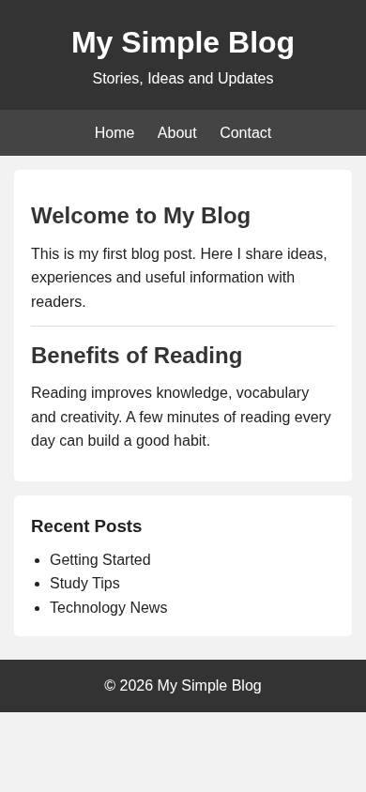
(c) Output Screenshots

1. Mobile View
On mobile devices, the blog content and sidebar appear vertically, one below the other.

2. Desktop View
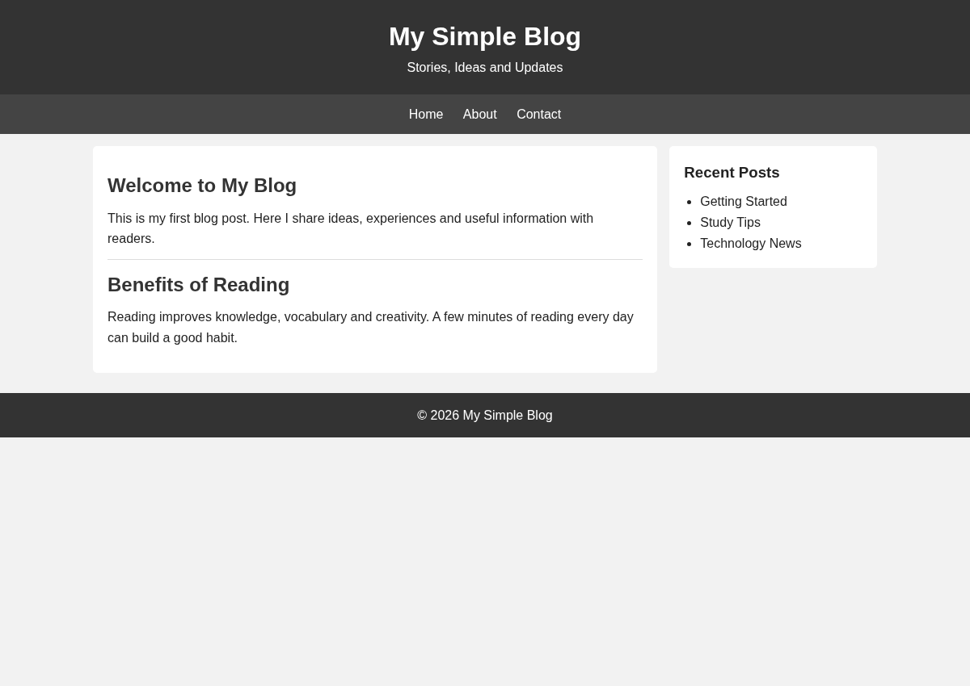
On larger screens, the main blog content and sidebar appear side by side.
How it works: The CSS media query @media (min-width: 768px) changes the layout from a vertical column to a horizontal row.

(d) Evaluate Accessibility and Readability
- Readability: Clear headings and appropriate font sizes make blog posts easier to read.
- Responsive design: The layout adapts to mobile and desktop screens.
- Accessibility: Semantic HTML elements such as <header>, <nav>, <main>, and <footer> improve accessibility.
- User experience: Consistent spacing and a simple navigation bar help users find information easily.
Conclusion: A mobile-first blog layout provides readable content on small screens and uses media queries to create a wider layout on larger screens.

Question 5: JavaScript Event Handling for Dynamic Menu - Marks(4)
Suppose that a website includes a dynamic menu that responds to user interactions.
(a) Identify appropriate JavaScript events for menu interaction.
(b) Design event handling logic for menu toggle functionality.
(c) Implement interaction for user actions (click/hover).
(d) Evaluate performance and suggest improvements.

(a) Identify Appropriate JavaScript Events
The following JavaScript events are useful for dynamic menu interaction:
- click – Opens or closes the menu when the user clicks the menu button.
- mouseover – Displays a menu when the mouse pointer moves over an element.
- mouseout – Hides the menu when the mouse pointer moves away.
- keydown – Allows keyboard interaction, such as closing the menu using the Escape key.

(b) Design Event Handling Logic for Menu Toggle
JavaScript uses event listeners to respond to user actions. When the user clicks the menu button, the classList.toggle() method adds or removes a CSS class to show or hide the menu.

(c) Implement Interaction for Click and Hover
The following simple example uses HTML, CSS, and JavaScript in a single file.

Complete Code (index.html)
The following code has been run successfully. It includes HTML, CSS, and JavaScript in one file.
<!DOCTYPE html>
<html>
<head>
<title>Dynamic Menu</title>
<style>
body {
font-family: Arial;
margin: 0;
text-align: center;
background: #f2f2f2;
}

header {
background: #333;
color: white;
padding: 18px;
}

button {
margin: 20px;
padding: 10px 16px;
background: blue;
color: white;
border: none;
cursor: pointer;
}

.menu {
display: none;
background: #444;
padding: 15px;
}

.menu.show {
display: block;
}

.menu a {
color: white;
text-decoration: none;
padding: 15px;
}

.menu a:hover {
color: yellow;
}
</style>
</head>
<body>

<header>
<h2>My Website</h2>
</header>

<button id="btn">☰ Menu</button>

<nav class="menu" id="menu">
<a href="#">Home</a>
<a href="#">About</a>
<a href="#">Services</a>
<a href="#">Contact</a>
</nav>

<script>
const btn = document.getElementById("btn");
const menu = document.getElementById("menu");

btn.addEventListener("click", function() {
menu.classList.toggle("show");
});

menu.addEventListener("mouseover", function(e) {
if (e.target.tagName === "A") {
e.target.style.color = "yellow";
}
});

menu.addEventListener("mouseout", function(e) {
if (e.target.tagName === "A") {
e.target.style.color = "white";
}
});
</script>

</body>
</html>

(d) Evaluate Performance and Suggest Improvements
- Performance: JavaScript event listeners provide quick responses to user actions.
- Efficiency: classList.toggle() makes it easy to show or hide the menu.
- Usability: Hover effects highlight menu links and improve interaction.
- Accessibility: Add keyboard support and clear focus indicators for users who do not use a mouse.
Conclusion: JavaScript event handling makes the menu interactive by allowing users to open and close it with a click and highlight links on hover.

Output Screenshots

Menu Closed
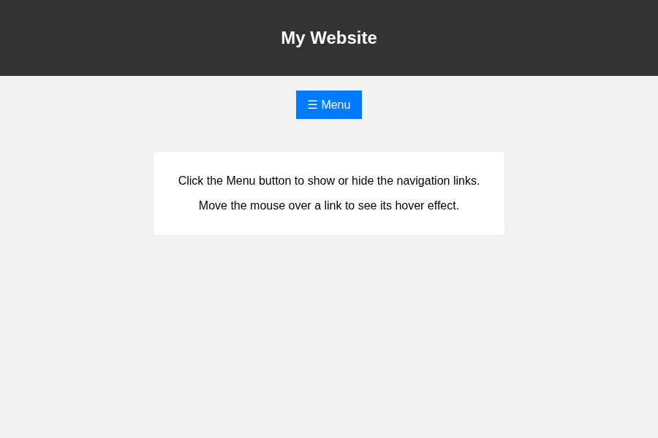

2. Menu Open After Clicking
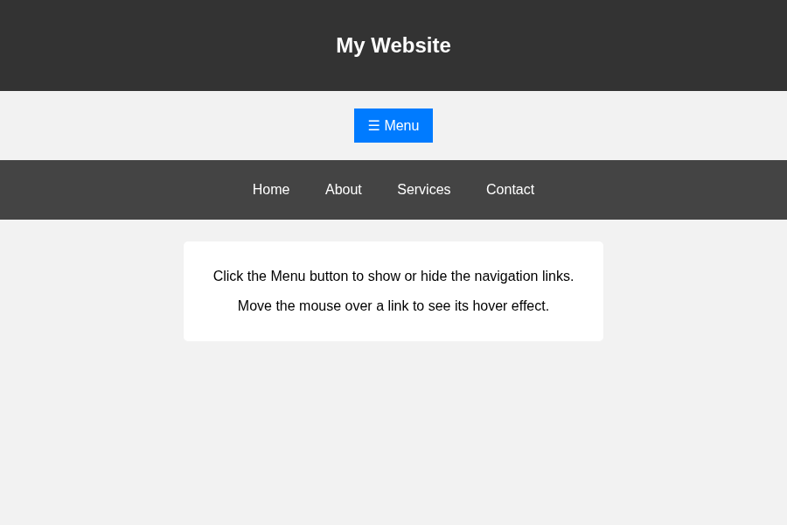

3. Hover Effect on Menu Link

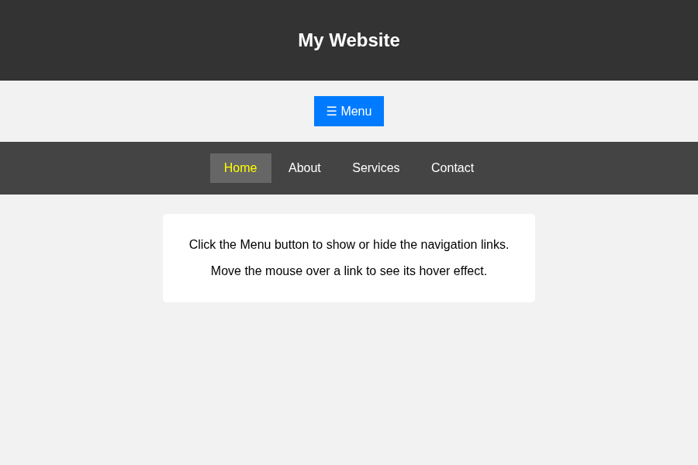

Code of Conduct:

I K.Nagesh Reddy2(192325083) (Name / Reg No) certify that this submission is my original work and that I have adhered to the guidelines specified for this assessment. I understand that any violation of academic integrity rules will result in disciplinary action.

Signature of the student:
nagesh

RUBRICS FOR CALCULATION:

Criteria | Weightage (%) | Level 4 – Exemplary (4) | Level 3 – Proficient (3) | Level 2 – Developing (2) | Level 1 – Beginning (1)
Understanding of Concept | 25 | Demonstrates complete understanding of design requirements and concepts | Good understanding with minor gaps | Basic understanding with some errors | Poor understanding or incorrect concepts
Design / Implementation | 30 | Well-structured, efficient, and responsive design implementation | Correct implementation with minor issues | Basic implementation with inconsistencies | Incorrect or incomplete implementation
Use of Tools (CSS/JS) | 20 | Effective and advanced use of tools/techniques | Appropriate use of tools | Limited or inconsistent use | Incorrect or minimal use
Analysis & Evaluation | 15 | Insightful analysis with strong justification and optimization | Good analysis with justification | Basic analysis with limited depth | Poor or no analysis
Documentation / Clarity | 10 | Clear, well-structured, and properly presented solution | Mostly clear with minor issues | Basic clarity, missing details | Poor or unclear documentation

